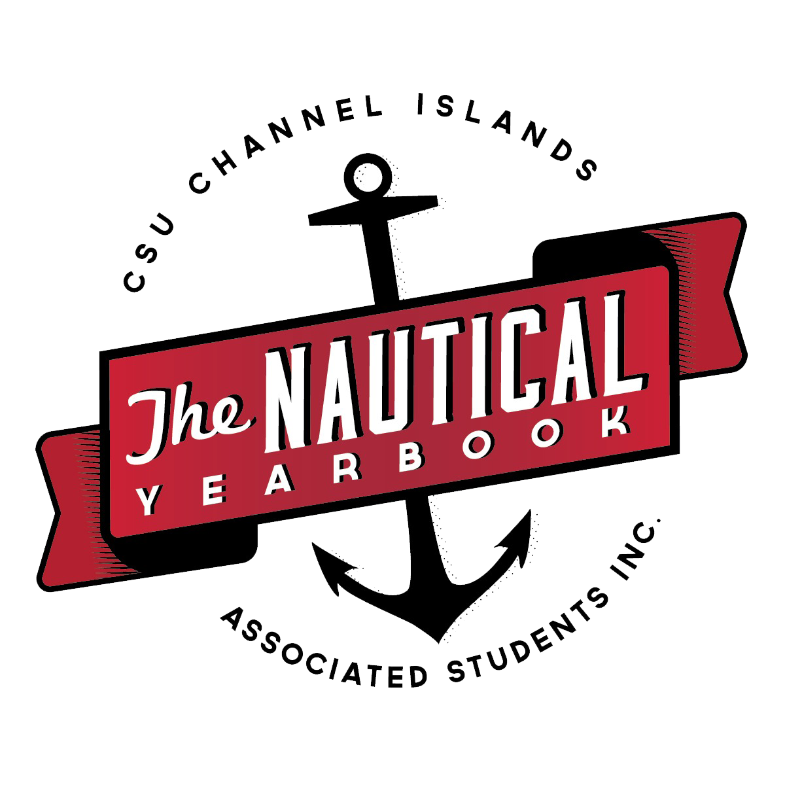
The Nautical

Duties and Responsibilities of Members

Article I: Membership
Section 1: The Nautical will uphold membership standards set by the ASI By-Laws, ASI Entity Constitution and University Policy.
Section 2: Any student who has attended at least 80% of the meetings during the academic year and contributed at least one piece of content (writing, art work, layout, information, etc.) shall be considered a member. All members must meet the minimum GPA requirements as set forth by the Office of Campus Programs; any position may be held by any undergraduate student, graduate student, and/or credential student.

Article II: Duties and Responsibilities
Section 1: The officers of the organization shall be the Editor-in-Chief, Visual Content Editor, and Student Publications Business and Marketing Manager. Editorial Staff positions may be added when needed at the discretion of the Editor-in-Chief. The Editor-in-Chief shall oversee all Editorial Staff position duties. Design positions can be created as needed and overseen by the Visual Content Editor.
Section 2: Executive Officers
- All level I, II and III employees are held to the duties and responsibilities laid out in the ASI Entity Manual, ASI Entity Constitution and position descriptions.
- Editor-in-Chief
  - Regularly works twenty hours weekly and holds regular office hours.
  - Meets regularly with CI administrators and ASI Professional Staff to seek guidance, advice and leadership direction. For complete list see ASI Entity Manual (University Support).
  - Serves on the ASI Board of Directors and attends all monthly ASI Board meetings.
  - Serves as the official spokesperson for the yearbook by creating a presence on campus representing the policies, views and opinions of the organization in its relationship with the campus and community-at-large.
  - Oversee the production of the yearbook;
  - Review all pages prior to their submission for printing;
  - Select and train the editorial staff;
  - Handle the budget, in conjunction with the Student Publications Business and Marketing Manager and Advisory Board, for The Nautical.
  - Facilitate the sales of all yearbooks.
  - Responsible for organizing all editorial meetings to ensure a successful publication of the yearbook and a meaningfully engaged staff.
  - Performs all duties as outlined in the Editor-in-Chief’s position description.

- Visual Content Editor
  - Regularly works twenty hours weekly and holds regular office hours.
  - Work directly with the Editor-in-Chief to ensure smooth, timely operation of the publication and to maintain a meaningfully engaged editorial staff.
  - When the Editor-in-Chief is absent or unable to perform their duties, the Visual Content Editor assumes the responsibilities of the Editor-in-Chief.
  - Attends all editorial staff meetings (attendance is not required when academic conflicts are present or due to emergency circumstances).
  - Advise the Editor-in-Chief concerning yearbook theme, design, layout, content, deadlines, and expenses.
  - Secure, manage, organize, select and caption the photographs and graphics to be placed in the yearbook, ensuring each image has the correct credit(s) and captions.
  - Ensure a timely publication of the yearbook by setting and meetings quarterly deadlines and ensuring that all photography, layout and design deadlines are met.
  - Oversee the printing and production of the annual publication.
  - Collaborate with the Editor-in-Chief in developing a marketing campaign to increase campus awareness of yearbook sales.
  - Serve as a representative for the yearbook, acting as a presence on and off campus, representing the policies, views and opinions of the organization in its relationship with the campus and community-at-large.
  - Work closely with photographers and editors to ensure they receive assignments, meet deadlines and objectives and to provide input for any visual and editorial content.
  - Performs all duties as outlined in the Visual Content Editor’s position description.

- ASI Student Publications Business and Marketing Manager
  - To attend all, ASI trainings, leadership staff meetings, leadership development seminars and budget meetings.
  - To abide by the ASI Bylaws, and The Nautical’s constitutions as definitive governing documents.
  - Meet with the ASI Student Programs Coordinator weekly.
  - Attend ASI committee meetings and other required meetings related to this position
  - To maintain effective and regular communication with The Nautical staff.
  - Coordinate, update and maintain marketing schedules/plans for each entity
  - Assist with the promotion of The Nautical, its leadership opportunities for students, and market these opportunities to generate increased membership.
  - Market and promote entity related sales
  - To regularly attend The Nautical editorial staff meetings (attendance is not required when academic conflicts are present or due to emergency circumstances).
  - To regularly attend weekly The Nautical executive officer meetings.
  - To assist The Nautical Editors in Chief in the development and presentation of an annual budget, as related to revenue, for each entity.
  - Support the maintenance of updated tracking budgets and record of annual budget report notes.
  - To hold regular office hours and to publicly post updated office hours each semester.

Section 2: Nautical Staff
- Secretary
  - Send agenda and required documents to Nautical team one week prior to meeting.
  - Take minutes during Nautical General Meetings including roll call.
  - Be the point of contact regarding meetings, documents, and information.
  - Works under the Editor-in-Chief in conjunction with the members of The Nautical.

- Photographer
  - Photograph various events and projects on campus as assigned by the Editor-in-Chief.
  - Must submit all photos to Visual Content Editor by assigned deadlines.
  - Ensure all photo content brought in has been edited to ensure manageable work load for Visual Content Editor
  - Photos must be high quality
- Writer
  - Provide journalistic coverage of various events and projects on campus as assigned by the Editor-in-Chief.
  - Must submit all content to the Editor-in-Chief by assigned deadlines.
  - Must follow the AP Style writing guide

- Copy Editor
  - Proofread all articles after submission and delivers to Editor in Chief
  - Ensure the articles meet the Nautical writing style guidelines.

- Social Media Manager
  - Create visuals, text, and any content for The Nautical social media accounts.
  - Frequently post ensuring the accounts are active; also responding to any messages.
  - Works under the general direction of the Editor-in-Chief and Visual Content Editor

- General Members
  - Contribute event information, ideas, and content for the Nautical.

- Officers shall be removed from office when The Nautical team believes they have not upheld the duties and responsibilities listed in this constitution. Removal will occur upon a 2/3 consensus of the executive team.
Section 3: Amendments
- Proposals for amendments to the constitution shall be ratified upon a 2/3 consensus of the current members.
- The constitution shall be ratified by its members by a 2/3 consensus of the current members.

Updated: 4/30/18

